Loch Raven Academy - Visual Art Magnet
Summer Assignment for Incoming 7th Graders
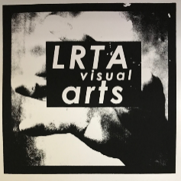
- Exterior/Landscape (20 points)
- Design Your Own Project (20 points)
***Due/Graded: the 2nd week of school***
General Information: These works of art will go towards your portfolio for 7th grade. The summer assignments are meant to keep your drawing skills sharp and to help you stay involved with making art over the summer months. We ask you to complete the following assignments so we can measure how well you do homework, how you apply your talent, and how well you can follow directions and work independently.

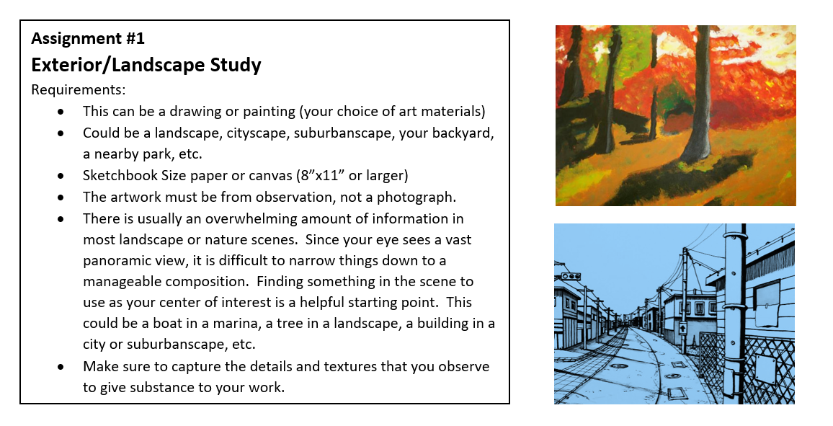

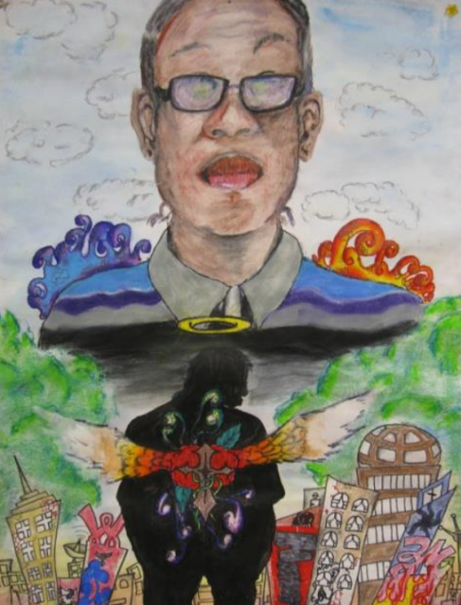
Assignment #2
Design Your Own Project
Your choice of art materials
Directions:
- Develop a style that you like is satisfying and self-expressive. There is nothing to lose from trying a wild idea you have. Some of the most creative new ideas grow out of mixing old ideas in new ways.
- First think of the word design. You are going to be an artist who designs his or her own learning experience. What type of project would you like to design? (nature, objects, animals, vehicles, landscape, cityscape, people, travels, plants…). If you need a reference picture, find an image in a book, magazine, internet or take your own photograph.
- Now, you need to think about the composition.
  - Is there a border? Use a ruler.
  - What orientation will the paper be? Landscape or Portrait?
  - What will I place in the background, foreground and middle ground and what will be the focal point?
  - What art elements will I focus on?
  - Will my work be abstract, realistic or tell a story?
  - What materials will I use?

